CSA1708-ARTIFICIAL INTELLIGENCE
LAB EXPERIMENTS
Program 4 : Python Program for Crypt-Arithmetic Problem
Aim
To develop a Python program to solve Crypt-Arithmetic problems (such as SEND + MORE = MONEY) by assigning unique digits from 0 to 9 to each letter to satisfy the arithmetic equation without leading zeros.
Algorithm
1. Extract all unique alphabetic characters from the crypt-arithmetic words (e.g., 'S', 'E', 'N', 'D', 'M', 'O', 'R', 'Y').
2. Verify that the total count of distinct characters does not exceed 10 (the available decimal digits 0-9).
3. Identify the leading letters of each word ('S' and 'M'), imposing the constraint that leading letters cannot be assigned the digit 0.
4. Generate permutations of distinct digits from 0 to 9 corresponding to the unique letters using itertools.permutations.
5. For each generated digit assignment:
6. a. Check if any leading letter is assigned 0; if so, skip to the next permutation.
7. b. Compute the numerical integer value for each word according to positional base-10 arithmetic.
8. c. Verify whether the arithmetic equation holds true: Word1 + Word2 == ResultWord (i.e., SEND + MORE == MONEY).
9. If the equation is satisfied, record the letter-to-digit mapping and the verified numerical equation.
10. Display the solution and terminate search upon finding the valid assignment.

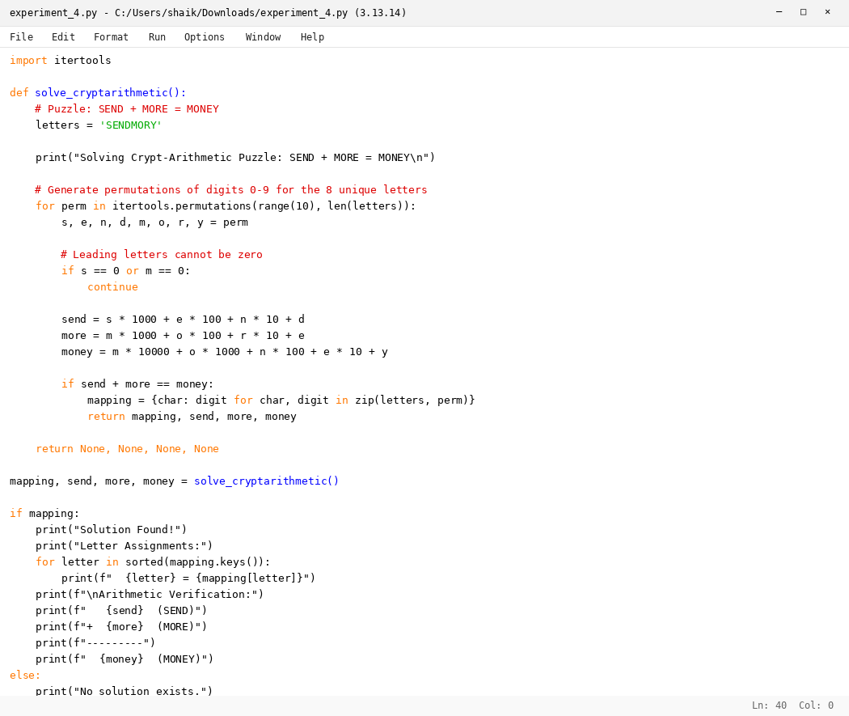

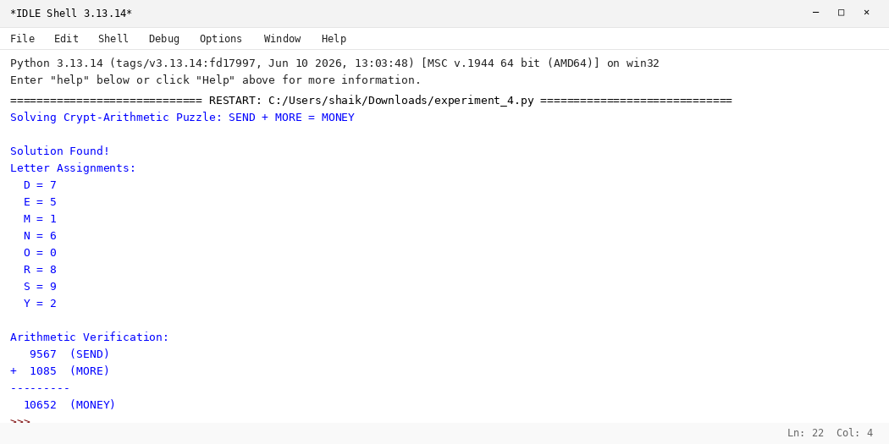

RESULT
Thus, the Crypt-Arithmetic Problem was solved successfully using Python.

